As an important part of our school’s commitment towards continuous improvement and excellence, students are encouraged to set personal learning goals and take ownership of the grades they earn. Parents/Guardians, along with students, are encouraged to monitor progress using the Canvas online gradebook so that no one is surprised by a report card grade.

Categories from which points are earned are Homework, Classwork, Warm Ups, Tests/Quizzes, and Projects. With the exception of Homework and Warm Ups, the amount of points assigned is determined by the length, difficulty, and learning Standard(s) of the particular assignment.

Final Quarter Grade = Total Points Earned
(Grade Average) Total Points Possible

Homework
Assigned regularly – most are due the next class meeting unless
otherwise specified
Must be neat, completed in pencil, and ALL WORK SHOWN
Is checked, when due, and earns:
- 2 points if complete with work shown, neat, and in pencil
- 1 point if at least half complete, no work shown, or done in ink
- 0 points if missing when due or unsatisfactorily done
* 1 point will be restored to a grade for correcting a missing or late
assignment anytime during the quarter
** Incentives for homework completion will be provided!
Any missed homework, due to an excused absence, may be turned in within two class periods, after returning to school, for full credit. Students are expected to obtain copies of missed work either from my website, or parents may request to pick up missed assignments by calling Student Services at (410) 313-5520.

Warm-Ups
- Must be completed daily in a steno pad stored in the classroom
- Are checked daily during class
- Are graded after every 5 activities as follows:
- 2 points for attempting answer and showing work
- 1 point for correct/corrected answer

Class Materials
Students should come to class prepared with the following supplies every day:
- Agenda Book for recording assignments/announcements
- several sharpened pencils with erasers
- Math section in binder with loose-leaf paper or a separate, 1 inch binder used exclusively for math
- Stenographer’s notepad (spiral at the top)
- Whiteboard marker
Rulers, compasses, protractors, and calculators will be supplied by the teacher as required.
A textbook will be assigned. It should be kept at home as a reference for the student, to be returned at the end of the school year.
Class website- corneliusmathmatters.weebly.com
Quizzes and Tests
Most quizzes and ALL tests are announced. Adequate time will be provided for preparation. Students, who are absent on the day of an announced test or quiz, will be expected to complete the assessment on the day they return to class.

Getting Help
I am available on Tuesday mornings, starting at 7 a.m. through the end of homeroom time. Also, I will provide additional support during the Wednesday Advisory period and after school on ______________ through the Math Coaching Intramural program or by appointment. Transportation home will need to be provided.
Communication between home and school is essential to the educational process. I encourage parents/guardians to call the school, write a note in the Agenda Book, or email me whenever there is a question or a concern. The best time to reach me is before or after school, or during my Planning Period. I will respond in a timely manner.
I look forward to partnering with you and having a successful school year!
Nancy Cornelius

Please sign and have your student return the detachable portion below to indicate that you have read and understand the expectations for math class. Your student should retain this document, in his/her math binder, as a reference during the school year.

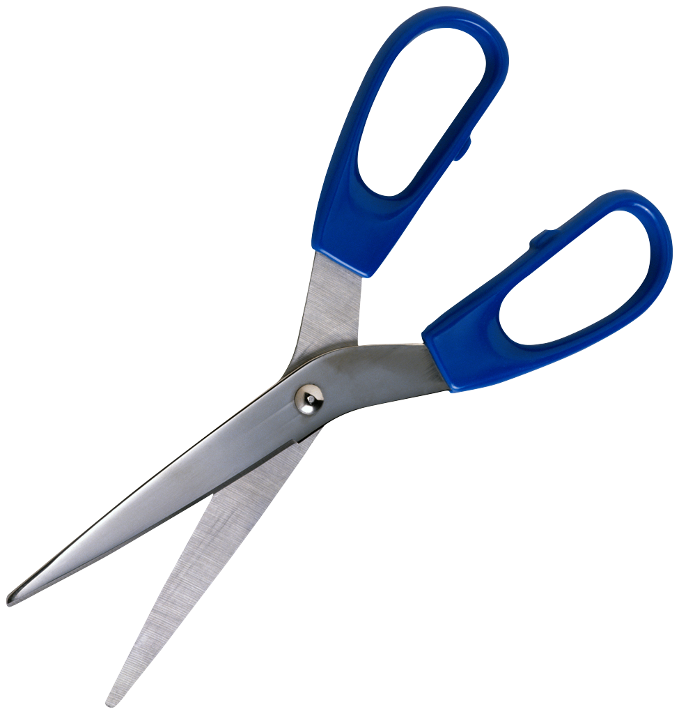
--------------------------------------------------------------------------------

I have reviewed Mrs. Cornelius’ Guidelines and Grading Policy document with my student and understand how my student will earn his/her grade in the class, the needed materials to be brought to class daily, and when my student may receive additional help throughout the school year. I know how to contact Mrs. Cornelius with any questions/concerns that I may have during the school year.

Student Name_______________________ Period____

Parent/Guardian Signature______________________________

Date__________

Question(s)? __________________________________________

HOW TO MAKE THE GRADE – Math Homework

Directions: Carefully read the Guidelines and Grading Policy that you were given in class today. Use this information to complete each statement and show your understanding. Don’t forget to get a parent/guardian to sign the tear-off portion and bring it to school, along with this completed assignment, to earn your first grade in Math Class!

- Homework that is completed in pencil, with work shown, and on time is worth ____ points towards your grade.

- All tests and most quizzes _____ be announced, and time will be provided for __________.

- If homework is completed with pen, or if no work is shown to support the answers, _____ point(s) will be earned.

- A ruler, calculator, compass, and protractor do not need to be brought to class, because these materials will be supplied by ______________.

- You will have math homework assigned ____________.

- Your spiral steno pad is used to complete __________ and will be stored in the classroom.

- Warm Ups will be graded after five are completed and can earn a maximum of ____ point(s) each.

- If you are absent, you will have ____ days to make up the work and receive full credit.

- Your math textbook should be kept at ___________ unless it is requested to be brought to school.

10. Besides homework and warm ups, you will earn points toward your
grade by completing tests/quizzes, bringing in assigned projects,
and ____________.

11. A test/quiz that is missed due to an excused absence from
school, will be made up ______________.

12. ____________ is responsible for keeping track of his/her
progress using Aspen the online grading program.

13. Mrs. Cornelius is available for extra help on _____________
mornings (starting at 7 a.m.) and after school on ___________
or by appointment.

Three math skills that I really understand well are:
a)

b)

c)

Three math topics that I would like to learn more about or feel unsure about are:
a)

b)

c)

Student Question(s)/Comments?

